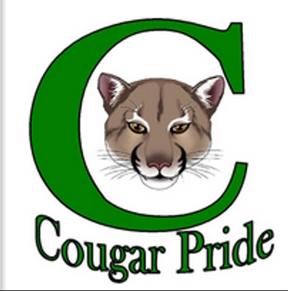
Dear awesome students, August 17, 2015

My name is Racquel Ward-Zamora. You may call me Ms. Zamora, Ms. Ward, Ms. W, or Ms. Z, but you may not call me “Hey Teacher!” I am writing you this letter to introduce myself because I am new to this school. First off, I just moved here from El Cerrito, California. It was a very exciting, but stressful move. I now live in Turlock and I love being back in the Central Valley. I can’t tell you how much I missed taco trucks!
I had a lot of fun teaching at El Cerrito High School the past two years and I am excited to teach middle school this year. This summer I went camping in Lake Berryessa which is North of here. This was a big deal for me because I DO NOT like bugs! I like going to the dog park near my house. I live with my spouse and our two dogs. They are very good dogs and knows how to sit, stay, and come on command.
Of course the thing that I did the most this summer was…. sleep! Anyone who knows me they will tell you that my favorite thing to do is sleep! Sometimes on the weekends I sleep almost 12 hours! One more interesting thing about me is that I just graduated from graduate school. I am looking forward to being your teacher this year. I can’t wait to get to know you better and to support your educational journey.
Let’s make this a great year,

Mrs. Zamora

